Early Years Approach to Reading at Home

In Early Years, Prep to Year 2, our focus for home reading is to encourage a “love of literature”,
a sense of fun and enjoyment, improved comprehension and confidence in expression and
fluency of reading. The purpose of home reading is for children to enjoy reading with a
significant person in their life and to develop a sense of value for reading.
To achieve these goals, we encourage our students to read a wide variety of texts with a
diversity of topics and with a range of difficulty.
As children will be reading a variety of texts, they will need differing levels of support to
engage with the text. One strategy to allow this to happen would be the: reading to, reading
with and reading by strategy. This strategy involves a gradual release of adult support as the
reading becomes more independent for the child.
READ TO the child by adult: | READ WITH the child in  partnership with adult: | READ BY the child as the  adult listens:
Appropriate if…  • the text is challenging  • to inspire children to  want to read or  • if it is a family favourite  text. | Appropriate if…  • engaging a child with a  text containing tricky  concepts that are a little  beyond your child’s  capabilities, but  manageable with help. | Appropriate if…  • the child is confident  with the text  • the child makes few  mistakes, reads easily  and has a solid  understanding of the  text  • the purpose is to build  confidence and fluency  in the reader.  • the purpose is about the  child experiencing  success as a reader.

How will I keep track of my child’s reading experience?
We recognise that home life is a busy one; however, reading daily with your child is the most
important habit to develop at home. To help maintain balance in being read to, read with
and read by themselves, teachers will provide a template (Reading Log) for you to monitor how you are travelling with this priority.
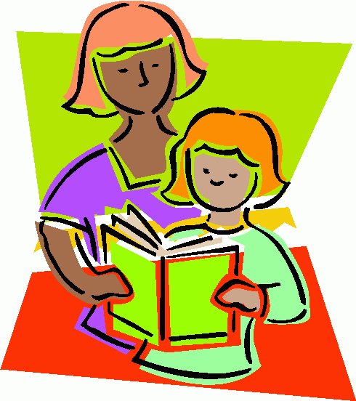
Children learn to read by:
• seeing important people in their lives read
• being read to every day
• seeing themselves as readers and
• having a go.

Keys to Home Reading:
1. Create a happy atmosphere.
2. Be encouraging and supportive.
3. Keep the session short (little and often).
4. Make if fun!
5. Get everyone involved.
6. Chat about the text.
Reading is about making connections –  making connections when reading supports  comprehension | Reading is always about making meaning –  reading must always have purpose, e.g. to  have fun or to learn something new
Ensure the child makes connections to the  text:  • Have you ever felt like that?  • That reminds me of…..  • Wouldn’t that be exciting?  • This is like that other book…..  • I’d love a puppy too! | If the child loses the meaning gently prompt  them:  • Does that sound right to you?  • Let’s just check back on the previous  page…..  • What’s happened so far in this part?  • Hang on, I’m confused….

What should my child be reading?
A wide variety of texts is important:
• At times levelled readers will be provided by the school
• Students will choose texts from our school library
• We ask for your partnership in selecting real-world texts in context. Examples of these
are: reading at breakfast (the back of the cereal box), reading the front
page of the newspaper, sharing a magazine, a map of a recent visit to Sea World, reading and co-authoring of the shopping list prior to the
grocery shop, reading the choices for tuck-shop order, sharing the school or class
newsletter, reading together a menu at a restaurant, looking at a bus or train
timetable, environmental print such as reading road signs or shop front displays etc.
• Visiting your local library and borrowing books is a way to build engagement with
reading
• Purchasing a book with birthday or pocket money (your home library)
• Searching for online texts on a topic of interest to the child
• Listening to audio books and following along with an audio book using the hard copy.

Often a child will read the same text over a number of nights. This is a great thing and should
be encouraged! This supports the development of comprehension, fluency, expression, sight
word vocabulary and increased confidence as a reader.

Thank you for your help in creating confident, capable and happy readers.

Source: https://kweb.bne.catholic.edu.au/LandT/Curriculum/LearningAreas/English/Documents/Home%20reading%20flyer.pdf

